High-Level Design
Project Title: Setup and Configuration of Automated Testing and Release Process (CI)
- Overview
- Objective: To build a Jenkins infrastructure, capable of testing and releasing a next version of your monitoring system upon successful test.
- Scope: This project focuses mainly on the automated testing functionality of the first project, Domain Monitoring System. In this project we will use Jenkins and docker to create the automated testing's pipeline, and use Selenium and Pytest libraries for testing the project's code.

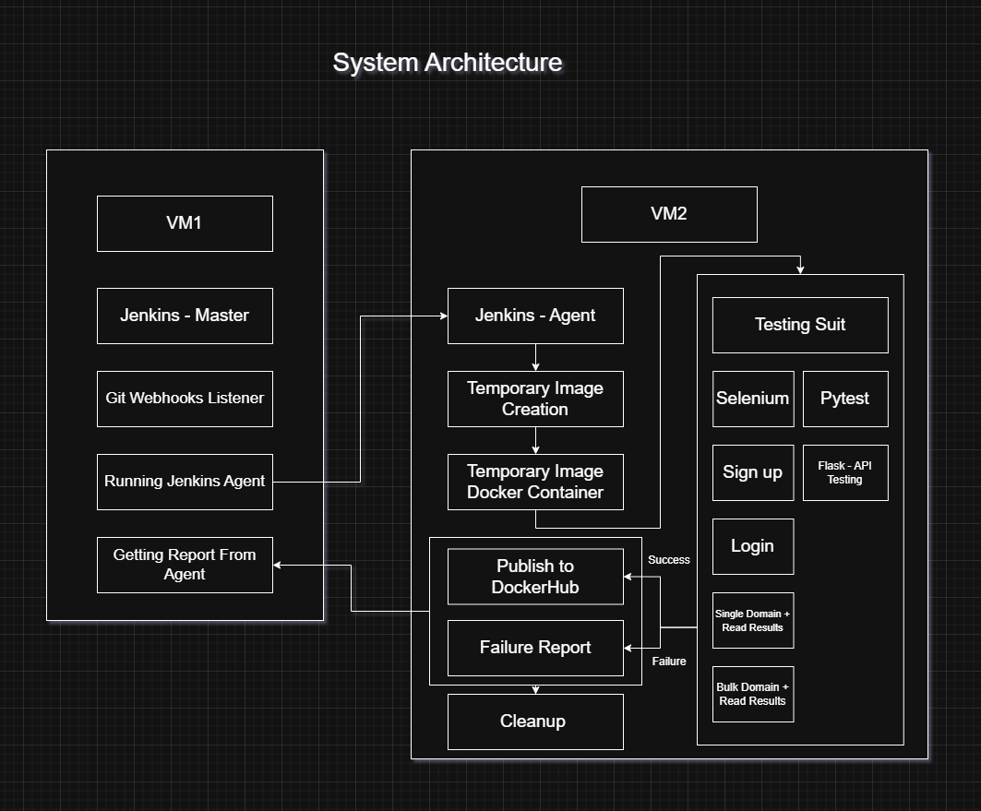
- System Architecture

- Architecture Diagram: The architecture is organized into two main units.
- Jenkins Master (Orchestrator): This VM machine supposed to run the Jenkins Master container (aka JM). The JM is the orchestrator, which listen to GitHub Webhooks and run the Jenkins Agent in response to changes in the project's code, and get an output from the Jenkins Agent upon successful or failure run.
- Jenkins Agent (Worker): This VM machine supposed to run the Jenkins Agent container (aka JA). The JA is the actual worker, which build the temporary image with a temporary version, run a docker container from the temporary image, run the Testing Suite. Upon successful testing's run promote the version of the image to the next semantic version and publish to DockerHub, and upon failure testing's run print a failure message with what test failed and why. After the successful/failure state cleanup by removing the temp image and cleaning up the workspace.

- Program Flow:
- Jenkins Master Flow:
- Webhook is sent from Github.
- Testing pipeline job triggered.
- The Jenkins Agent start executing the testing's pipeline.
- Jenkins Agent Flow:
- When triggered, JA starts creating the temporary image.
- Building a docker container from the temporary image.
- Running the temporary image container.
- Running the Testing Suite.
- Upon successful testing's run, promote the version of the image to the next semantic version and publish to DockerHub.
- Upon failure testing's run, print a failure message with what test failed and why.
- cleanup by removing the temp image and cleaning up the workspace.

- Key Features:
- Jenkins Master Node:
- GitHub Webhooks: when a push occurred to the project's GitHub repo, a webhook sent from GitHub to Jenkins Master server.
- Jenkins Pipeline: Running the pipeline and triggering the Jenkins Agent's job.
- Report: Printing the results of the past jobs to job's runs.
- Jenkins Agent Node:
- Temporary Docker Image: Creating a temporary image from the GitHub repo including all the dependencies.
- Temporary Image Docker Container: Running the temporary image on a new docker container.
- Testing Suite: Running the Testing Suite on the temporary image docker container.
- Testing's State: Checking the state of the testing, if successful, publish to DockerHub, else print failure report.

- Technology Stack:
- Infrastructure:
- AWS – VM Instances: two VMs instances to run two Jenkins containers.
- Docker: running the Jenkins container and other operations through docker containers.
- Jenkins Infrastructure: on each VM, run a Jenkins container, one as a master node (an Orchestrator), and one as a worker node (an Agent). Using JNLP wrapped as a Systemd service to ensure smooth connection. Use Jenkins master local IP address in your connection string.
- Testing Suite:
- Pytest: Using Pytest to perform testing against backend API.
- Selenium: Using Selenium to check the correctness of GUI operations for a set of known procedures.

